h. Sophie Louise
Paul Furr, Hybridizer
ADS REGION 14 SPRING MEETING JUNE 5-6, 2026
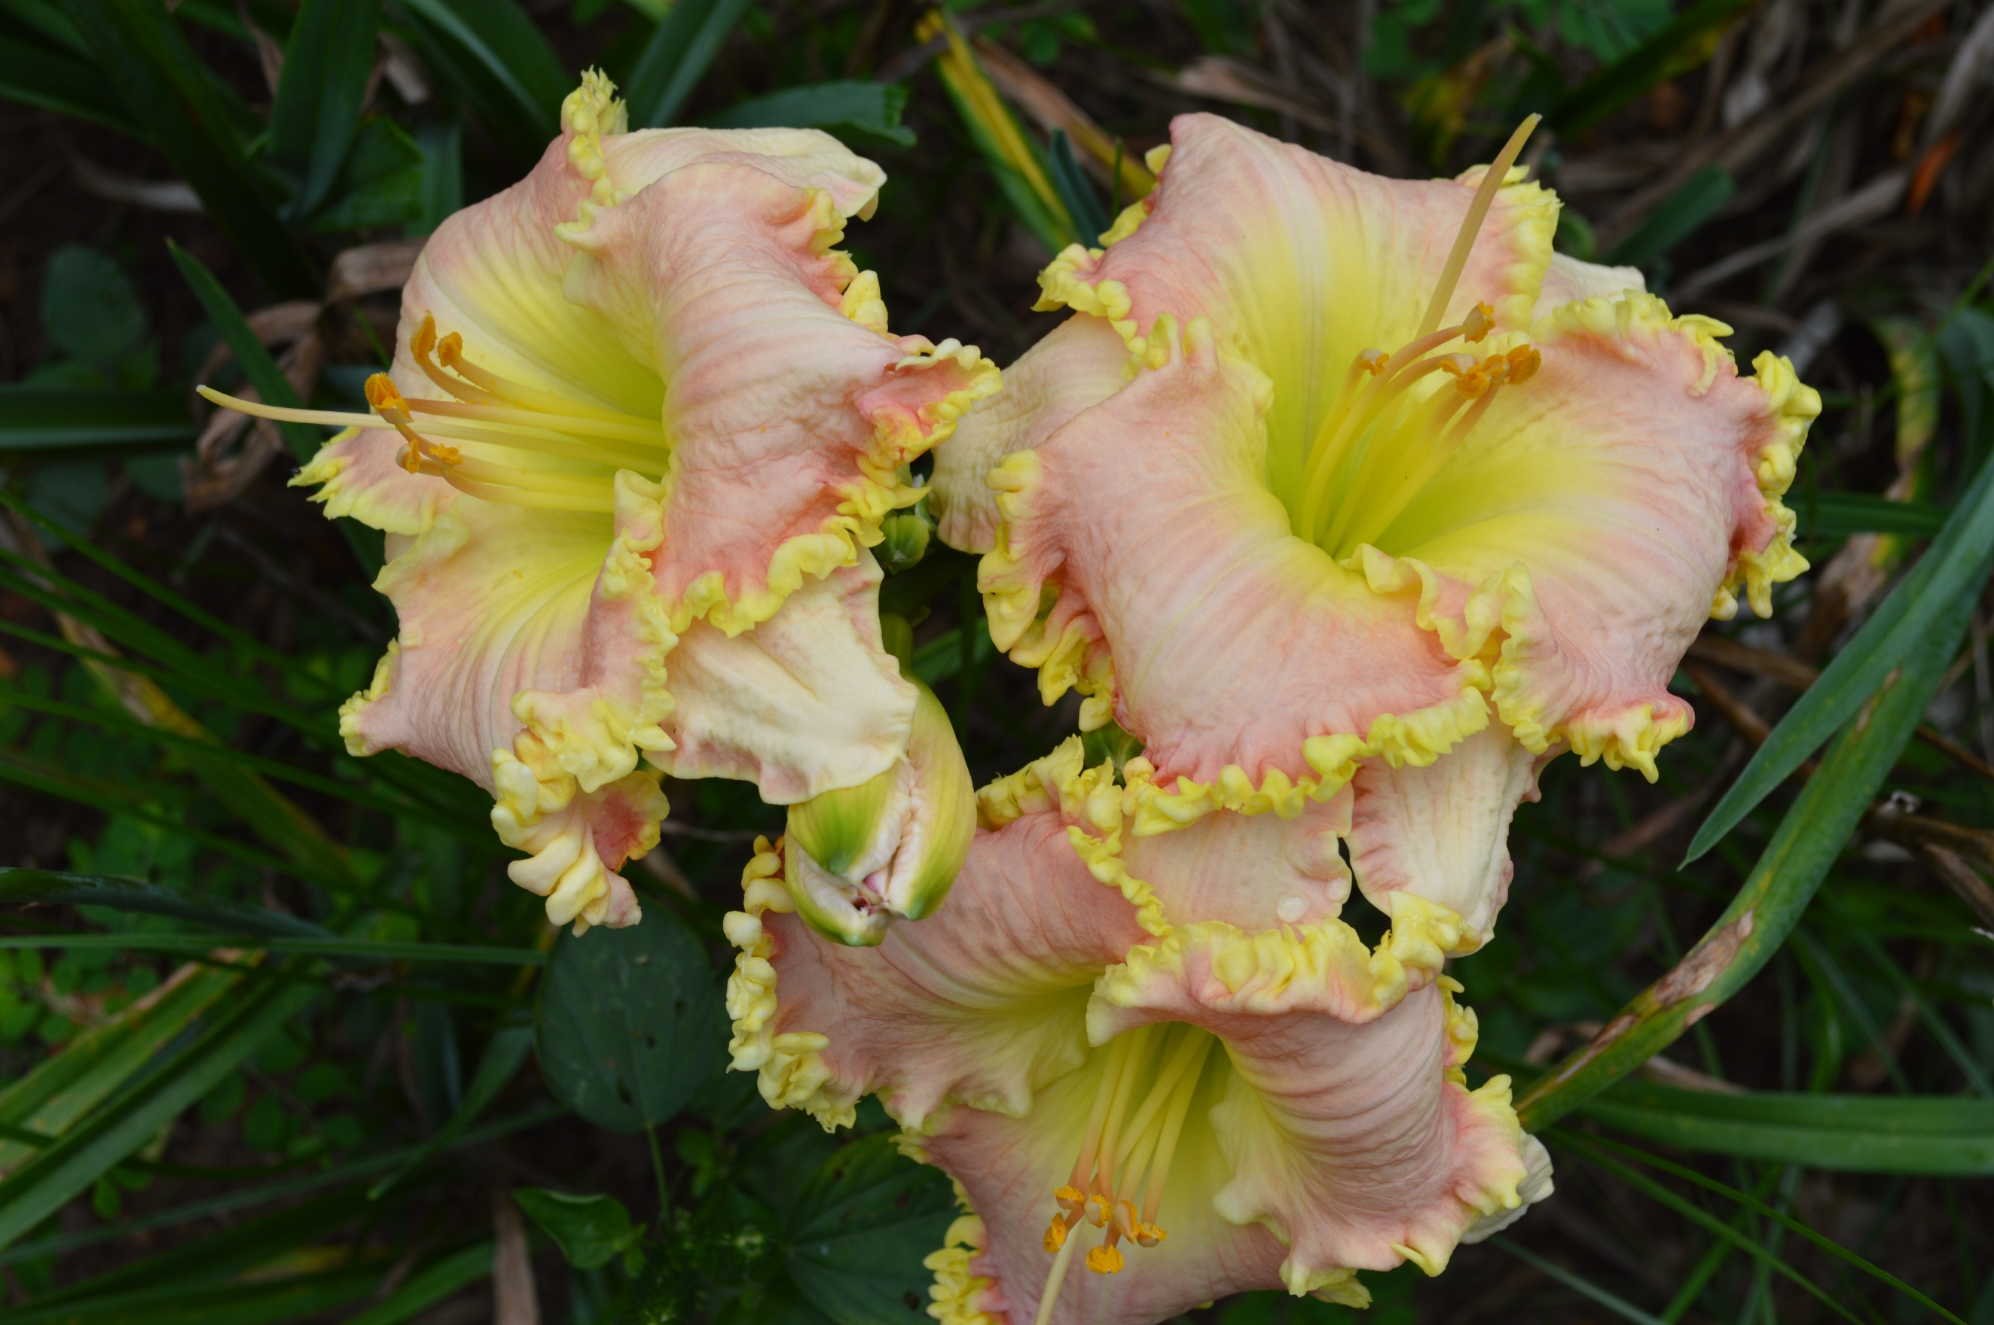

Host Club - MONTGOMERY AREA DAYLILY SOCIETY
St. Paul Lutheran Church, 4475 Atlanta Highway, Montgomery, AL 36109

Chairperson: Mary Rose Cronian Co-Chair: Terese Goodson
Registration: June 5, 2:00-5:00 p.m. Business Meeting June 5, 5:30 p.m. Dinner on your own.
Saturday June 6-Four Garden Tours begin at 8:00 a.m.
Saturday, June 6, Lunch 12:30; Dinner 5:30, followed by Awards Presentation/Region 14 Auction

Guest Speaker – TBD

Registration Fees: Mail Payment and Registration Form To:
Adult: $80 Teresa Hannah, Registrar
Youth: $40 2317 Loop Road
Tuscaloosa, AL 35405
Email: TeresaRonnieHannah@Yahoo.com
Make Checks Payable To:
Montgomery Area Daylily Society Contact Jason T. Fleishman, for other payment methods. JasonTFleishman@gmail.com (205) 886-9764

Hotel Block: Register by phone, 334-396-6300. Call Jennifer Cruz, Quality Inn,
Before 3:00 p.m., M-F: Room Rate: $100/night + Tax, Specify Queen or King
Rate is valid until May 31, 2026 Group Code: Daylily Meeting

Quality Inn & Suites
5035 Carmichael Road
Montgomery, AL 36106
Phone # 334-396-6300
**************************************************************************************************** Registration Form:

Name__________________________________________ Montgomery Area Daylily Society Member Yes/No_______

Youth #1___________________________________________ Youth #2___________________________________________________

Address: ___________________________________ City: ___________________________ State: _______ Zip Code____________

Phone:_______________________________Email:_____________________________________________Region:_________________

If you are a Regional or National Officer, please list your title: _____________________________________________
Do you need handicapped facilities or special dietary requirements? Yes_______ No _______

Give details if answer to either is yes:_________________________________________________________________________

Lunch Preference from SweetCreek Farm Market (Select one):

______________ Pimento Cheese Sandwich

______________ BBQ Sandwich

______________ Turkey Club Sandwich

_______________Ham and Swiss

Convention Cancellation Policy: Cancellations received before May 15, 2026 will receive a full refund; those received after will be reviewed on an individual basis. Registrations may be transferred to someone else after the May 30 cutoff date. Please notify the Registrar of any changes.

NOTE:
Region 14 Clubs are asked to donate one raffle item for the Fall and Spring meetings to help defray costs for host clubs. Proceeds from the raffle return to the hosting group.

Region 14 members/clubs are also requested to donate bare rooted/potted daylilies for plant tables sold at the meeting. Proceeds are donated to the host club. These plants sell for $7-15/double fan.

Jason Fleishman will be soliciting auction plants for the meeting. The proceeds from the evening auction return to Region 14 for expenses.

